Navy Medical Programs
ACTIVE DUTY OPPORTUNITIES AVAILABLE RESERVE OPPORTUNITIES AVAILABLE
• Competitive Pay • Part-time Service (One Weekend per
• Continuous Upward Mobility Month, Two-Weeks per Year)
• Up to $400,000 Sign-on Bonus • Up to $75,000 in Specialty Pay
Depending on Specialty • Up to $50,000 in Loan Repayment
• Additional Financial Incentives • Sign-on Bonuses available
• Full Medical and Dental Plans • Practice Close to Your Home and
• Advanced Training and Education Family w/ Flexible Service Options
Opportunities • Montgomery GI Bill
• 30 day of Paid Vacation per Year • Tricare Reserve Select Health
• Many More Benefits Insurance ($49.62 for an individual;
* Contact your Navy Recruiter for more information $197.65 for a family)

Additional ACTIVE DUTY AND RESERVE Privileges
- Servicemembers’ group life insurance (SGLI) $400,000 policy
- Miltary Commissary and Navy Exchange Privileges
- Access to Officer’s Clubs Worldwide
- Retirement Opportunities
- VA Home Loans
US NAVY RESERVES PROGRAMS
US NAVY ACTIVE DUTY PROGRAMS

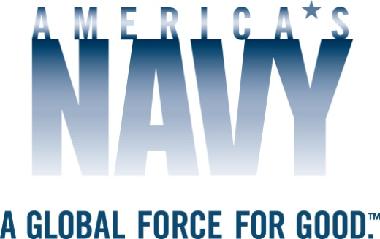

Please do not hesitate to contact your localNavy Recruiter for additional information or questions:

Charlotte Smith, LTJG, NC, USN
(352) 258-4851
Charlotte.e.smith@navy.mil

