Nursing Tip Sheet
From the Graduate Medical Education Office
February 8, 2017

New on Nursing Quick Links: Did you know that you can find what level of supervision is needed for residents/fellows and Adjunct Clinical Post Docs? You can search by:
- Last Name | 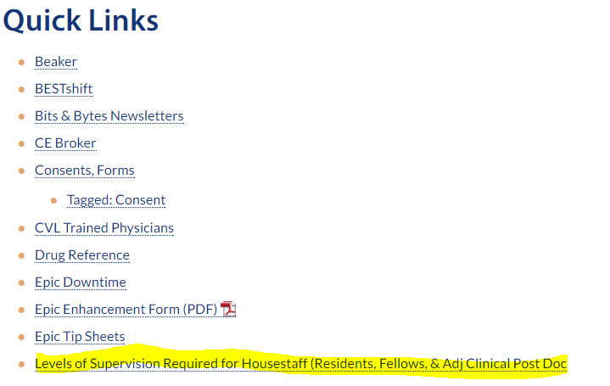
- Procedure
- CPT Code

https://bridge.ufhealth.org/shands-nursing/quick-links/

Definitions for Levels of Supervision
Direct Supervision - Supervising physician is physically present with the resident/fellow and patient (e.g. shoulder-to-shoulder).
Indirect Supervision: Available On Site - The supervising physician is immediately available and on site (e.g. in the building within a short walking distance).
Indirect Supervision: Available Off Site - Supervising physician is immediately available by phone and can be called in to provide direct supervision if necessary.
Indirect Supervision: Oversight - This is functionally independence for a resident/fellow. Residents/fellows who are capable of operating under oversight can also function as a supervising physician for more junior level residents/fellows.

Currently Available for the Following Programs:
ANE-Anes Cardiovascular | NS-Endovascular | PATH-Neuropathology
ANE-Anesthesiology | NS-Functional Neurosurgery Non-Approved | PATH-Pathology
ANE-Critical Care Medicine | NS-Neurological Surgery | PATH-Surgical Path Non-Approved ACGME
ANE-Pain Medicine | NEURO-Behavioral Neurology | PSYCH-Addiction Medicine
CFHM-Sports Medicine | NEURO-Clinical Neurophysiology | PSYCH-Child & Adolescent Psychiatry
DERM-Dermatology | NEURO-Neurology | PSYCH-Forensic Psychiatry
DERM-Dermatopathology | NEURO-Vascular/Stroke | PSYCH-Geriatric Psychiatry
EM-EMS | OBGYN-Obstetrics & Gynecology | PSYCH-Psychiatry
MED-Endocrinology | OPTH-Ophthalmology | RADONC-Radiation Oncology
MED-Gastroenterology | ENT-Otolaryngology | SURG-Acute Care Surgery Non- ACGME
MED-Hepatology | PATH-Bone & Soft Tissue Non-Approved ACGME | SURG-Surgery
MED-Geriatric Medicine | PATH-Cytopathology | SURG-Surgical Critical Care
MED-Infectious Disease | PATH-Gastrointestinal Path Non-Approved ACGME | URO-Urology
MED-Internal Medicine | PATH-Hematopathology
More Coming Soon!!!

