Dear Doctors,

First of all, Congratulations on your residency program at The University of Florida and welcome to
Gator Nation!

With your move to Gainesville I am here to help you find your new home. As a Realtor with Pepine Realty, it would be my honor to offer support for rental, purchase, and relocation services in Gainesville.
Pepine Realty is a “boutique agency” with a commitment to the community and more importantly to customer service. Betsy Pepine, Broker-Owner, MBA has been the #1 Selling Residential Agent and Team in Alachua County since 2011 and has been consistently ranked in the top 1% of Realtors in sales in Gainesville. She is also endorsed by Barbara Corcoran and Daymond John from Shark Tank.

I have attached links to my bio and my website for your convenience. My website will give you the ability to view homes in and around town at your price point and with the amenities you prefer. I look forward to helping you in any way I can.

https://www.pepinerealestate.com/agents/112554-Sherry-Shaara/
Sherry.PepineRealEstate.com

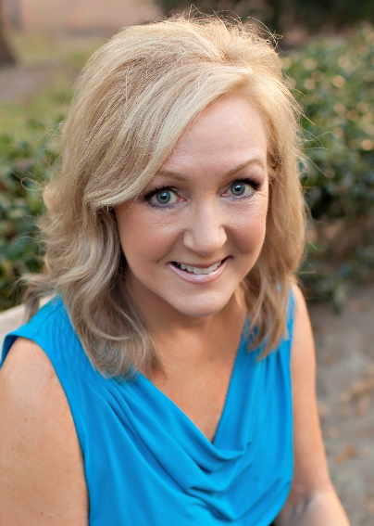
Sincerely,

SHERRY SHAARA
REALTOR®
(352) 278-4402
Email: sherry@pepinerealty.com
sherry.pepinerealestate.com

