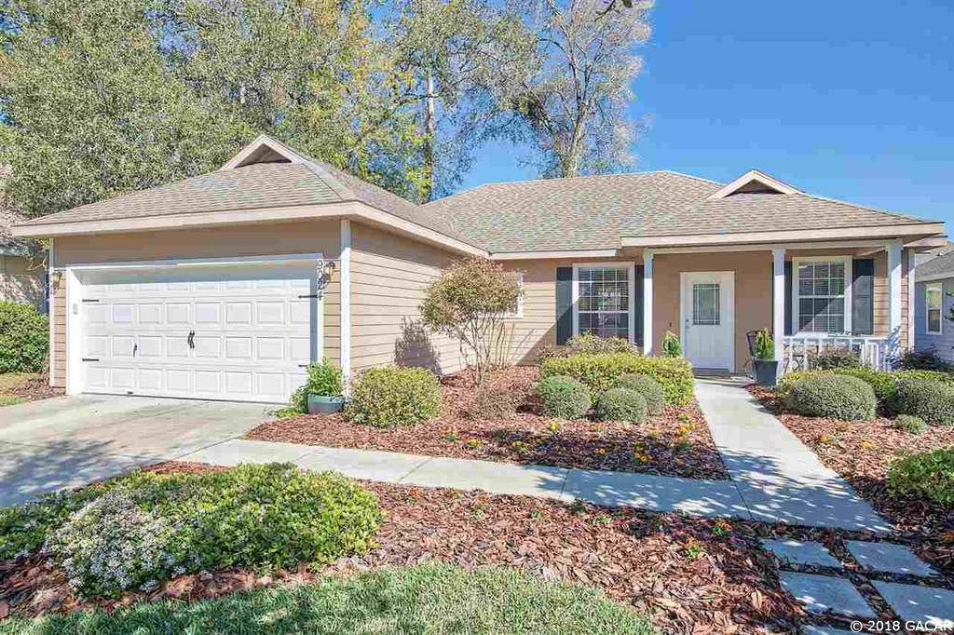
$239,999
3 bd, 2 ba, 1,402 sq,ft.,
9024 SW 79th Ave, Gainesville
Brittany- brittany.mathias@surgery.ufl.edu

