PERFECT HOME FOR RESIDENTS/FELLOWS/YOUNG ATTENDINGS FOR RENT
ADDRESS: 7985 SW 79th Lane, Gainesville, Florida, 32608
4 Bedroom 3 full bathroom (Built in 2015) – Asking $2150/month
Link for more pictures on Zillow: goo.gl/THDN5d 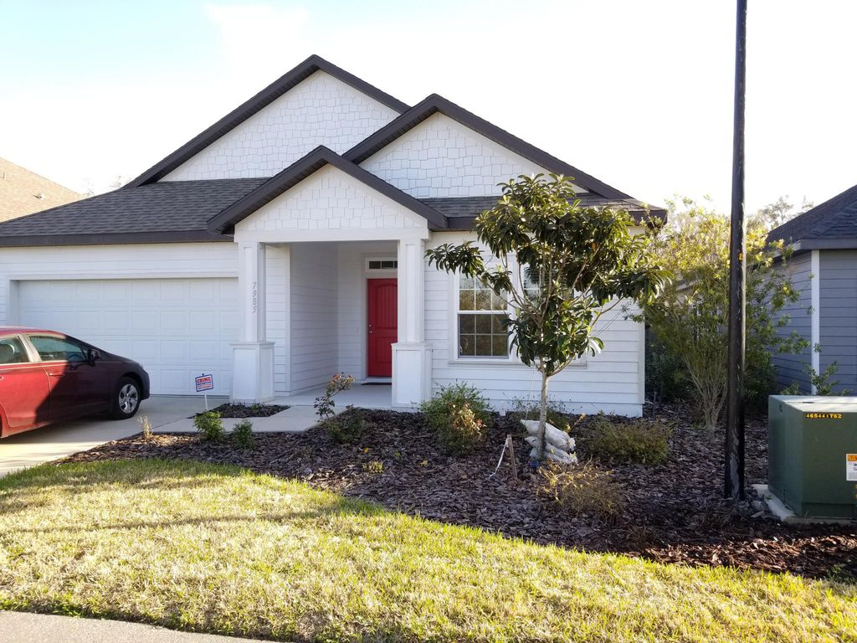

Beautiful and well-maintained 4 bedroom 3 bathroom 1972 sq.feet custom home on a private street in Longleaf Village community built in 2015. The community is full of young physicians and residents training at the University of Florida and perfect for a young couple or a family with small kids. Community has a large pool, tennis courts, child play areas. Our home is smoke free and pet free. Many upgrades have been done to the home including hardwood floors, under cabinet lighting, USB ports throughout the home, daylight LED lighting in all of the home, fenced yard, bathroom upgrades with double sinks and drawers, recess ceiling in bedroom and living room. Lots of natural light. Security system installed. Fiber-optic internet access with up to 1000 MBPs available through AT&T. Prefer to rent to physician or fellows or residents going to Shands or North Florida.Tenant pays for electric and water charges. No pets please.

CONTACT: Vik Khullar (347-884-4602 (prefer text) or email: vikas.khullar@medicine.ufl.edu )
