FEMALE ROOMMATE WANTED

BEAUTIFUL 2 BEDROOM 2 ½ BATH
TWO STORY CONDOMINIUM IN MONTICELLO
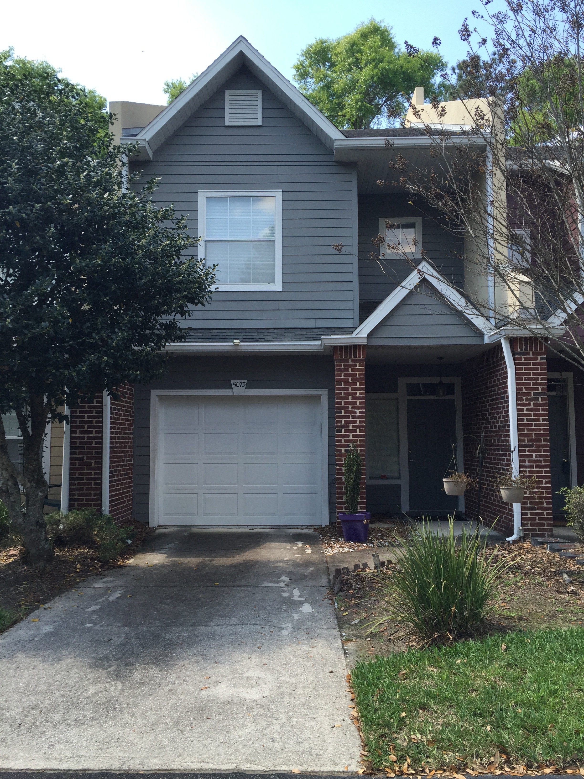

- Quiet community with clubhouse, pool and tennis court
- 10 minutes to Shands
- Directly across from Gainesville Health & Fitness Center
- ALL wood floor including bedrooms
- Two master suites with walk-­‐in closets
- Granite counter top in kitchen
- Washer/dryer, microwave, stove and refrigerator
- 1 car garage
- Outside deck
- Wired for security system

Rent: $650/month

Please Contact: E-mail: lindsey.johnson@medicine.ufl.edu
Or Call 321-298-4273

