Data Source Examples: APEs, ACGME Letters on Notification, ACGME Surveys, Case/Procedure Logs, Graduate Surveys, Internal Surveys, PEC minutes, etc. for sources of improvement areas.

“Citations & Concerns” should be linked to “Action Plans” in New Innovations. You may have:
- 1 action plan for 1 or more citations/concerns, or
- 2 or more actions plans for 1 citation or concern, or
- 1 action plan for 1 citation/concern

TIPs:
- Use two monitors if possible
- Use two browsers (e.g. Internet Explorer) to open your APE and use a second browser (e.g. Chrome) to open the Action Plan or Citations & Concerns in New Innovations.
- Copy and paste between the two as needed.

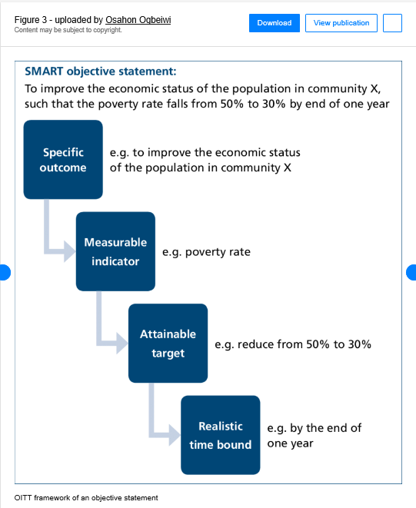

Example Concern
Title: Resident Survey: 80 Hours
Since MM/DD/YYYY
Source: RRC
Associate with the following: Program Quality
Details: “80-hour week (averaged over a four-week period)” program compliance rate of 75% vs national compliance rate of 91%”

Example Linked Action Plan
Title: 80-Hour Compliance
Goal Since: MM/DD/YYYY
Details of Goal:
SMART GOAL: Improve the 80-hour work week average compliance percentage for this residency program from 75% to at least 91% (2021 national average compliance rate) on the next ACGME resident survey by the end of the 2021-2022 academic year.
ACTION/IMPROVEMENT PLAN: 1) review baseline data: 1.a) NI data on logging compliance by resident, 1.b) violations by rotations, and 1.c) violations by person, 2) based on identified issues – 2.a) provide education for duty hour logging, 2.b) make changes to rotations that are identified as problematic for 80 hours, 2.c) internal anonymous Qualtrics survey prior to ACGME survey approximately mid-year on duty hours 3) monitor for compliance and maintenance of compliance after changes are implemented.
MEASURES: ACGME 2022 Resident Survey; GME office summary reports of violations; Program NI duty hour violation report by rotation; Program NI duty hour violation report by resident; internal survey of duty hour questions based on ACGME resident survey to be administered in Nov or Dec of 2021.
OVERSIGHT: Dr. J Shah, Ms. R Jones
Associate with the following: Program Quality
Uploads: 2021 Resident Survey indicating Issue, NI reports, internal survey results, 2022 Resident Survey

STEP BY STEP GUIDE for New Action Plans

You do not need to reformat prior actions plans

Where are Citations & Concerns in NI? NI → Administration → Program (white bar) → Citations & Concerns

Entering a New “Citations & Concerns”
Add new citation or concern:
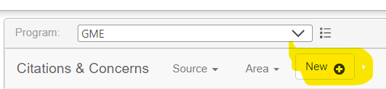
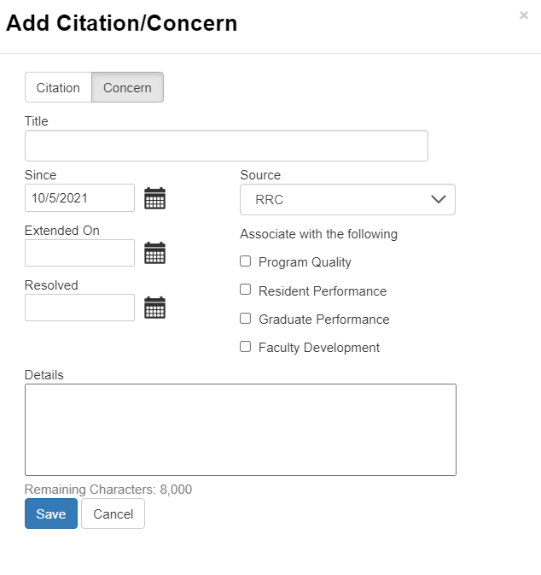
- If entering a new citation or concern/area for improvement (AFI), select Citation” tab OR “Concern” tab. Note that citations only come from the RRC.
- Enter a Title: e.g. Resident Survey: 80 hours
- Enter start date/”Since”
- Select Source: 1) “RRC” if in letter of notification or ACGME survey, OR 2) “GMEC” if from IPRC, OR 3) “PEC” if from your program evaluation committee/annual program evaluation
- Associate with the following: Select all that apply
- Details: enter details from resident survey e.g. “80-hour week (averaged over a four-week period)” --program compliance rate of 75% vs % national compliance rate of 91%”
- Click Save
Where are Action Plans in NI? NI → Administration → Program (white bar) → Action Plan

Entering a New Action Plan (Suggest using all caps on section headers as formatting is lost in NI and this helps readability)
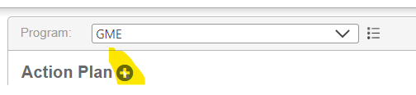
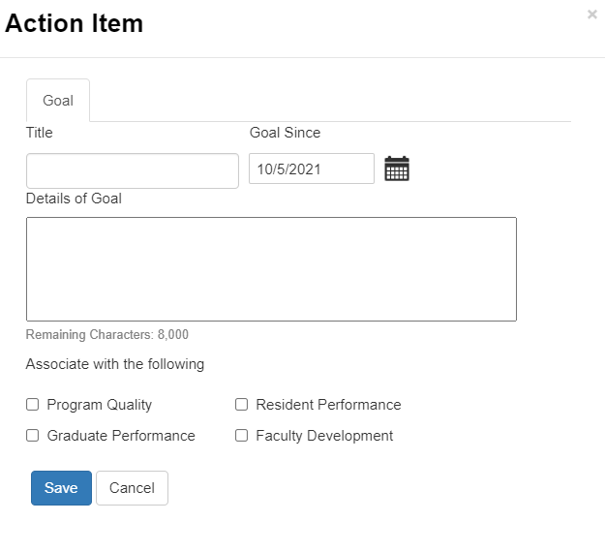
Complete the following:
“Title”: e.g. 80-Hour Compliance
Goal Since/Start Date: enter date…..
Details of Goal (previously called ISSUE): suggested formatting as a QI SMART GOAL:
Outline to follow:
SMART GOAL:_______
e.g. Improve the 80-hour work week average compliance percentage for this residency program from 75% to at least 91% (2021 national average compliance rate) on the next ACGME resident survey by the end of the 2021-2022 academic year.
ACTION/IMPROVEMENT PLAN: e.g.
1) review baseline data: 1.a) NI data on logging compliance by resident, 1.b) violations by rotations, and 1.c) violations by person,
2) based on identified issues –
2.a) provide education for duty hour logging,
2.b) make changes to rotations that are identified as problematic for 80 hours,
2.c) internal anonymous Qualtrics survey prior to ACGME survey approximately mid year on duty hours
3) monitor for compliance and maintenance of compliance after changes are implemented

MEASURES: _________ e.g.
- ACGME 2022 Resident Survey;
- GME office summary reports of violations;
- Program NI duty hour violation report by rotation
- Program NI duty hour violation report by resident
- internal survey of duty hour questions based on ACGME resident survey to be administered in Nov or Dec of 2021

OVERSIGHT: who will be coordinating/overseeing/doing the work, e.g. Program Director/APD’s Names

“Associate with the following”: check all that apply e.g. Program Quality
Click Save

Uploads: e.g. 2021 Resident Survey indicating Issue, NI reports, internal survey results, 2022 Resident Survey, etc.

Later --> Progress Updates:
- Provide date(s)
- Tag as “Progressing”, “Not Progressing”, “Closed-Successful”, Closed-Unsuccessful” OR “On Hold”
- Write note – e.g. The anonymous internal duty hour survey indicated no 80 hour duty hour violations by rotation. Upload any supporting documents to the Attachments Tab.

If action item is tagged as “Closed” – indicate what the outcome was using the Outcome Tab.
e.g. the 2022 ACGME resident survey indicated a 92% compliance rate for 80-hour duty hours. NI duty hour logs have zero reported duty hour violations during AY 21/22. [Upload any supporting documents to the Attachments Tab. Monitoring will continue.” OR state why unsuccessful and if you will implement an alternate plan, or if this is an item you have no control over, etc.

The ACGME will want to know what areas you have successfully improved and documentation for that improvement.

